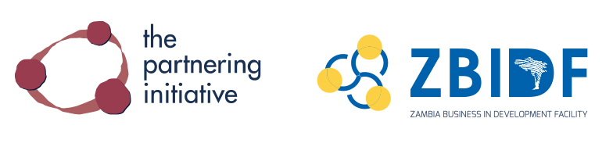

TOOL 2 PARTNERSHIP CONCEPT
Template for early communication
Use: To provide an early stage draft of the partnership idea to invite a more structured conversation with key partners.
Partnering phase: Scoping & Building

Introduction
• What issue/problem does this partnership address?
• What important context should the partners consider?
Justification for action
• What is the reason for collaboration? (Why is partnership the necessary solution?)
• How does the partnership address individual partners’ strategic priorities?
Partnership opportunity
• What is the potential over-arching goal partnership?
• What are the potential objectives of the partnership?
• What potential collaborative activities will the partners pursue to advance the partnership?

Potential partners, interests and roles
Partner | Organizational interest | Role
Potential Partner 1 | Partner 1’s potential interest… | Partner 1’s potential role…
Potential Partner 2 | Partner 2’s potential interest… | Partner 2’s potential role…
Potential Partner 3 | Partner 3’s potential interest… | Partner 3’s potential role…

Resources
• What potential resources (financial and in-kind) might be required to actualize the partnership?
• What potential resources (financial and in-kind) might be required to facilitate the partnering process?
Risk management
• What potential conflicts, concerns, risk might this partnership present?
• How might they be managed?

The Zambia Partnering Toolbook is available at thepartneringinitiative.org and www.zbidf.org

